**ITCS-6100 Group 1 Project Deliverable 2**

**5. Data Understanding – Exploratory Data Analysis + Dashboard**

Created an S3 Bucket

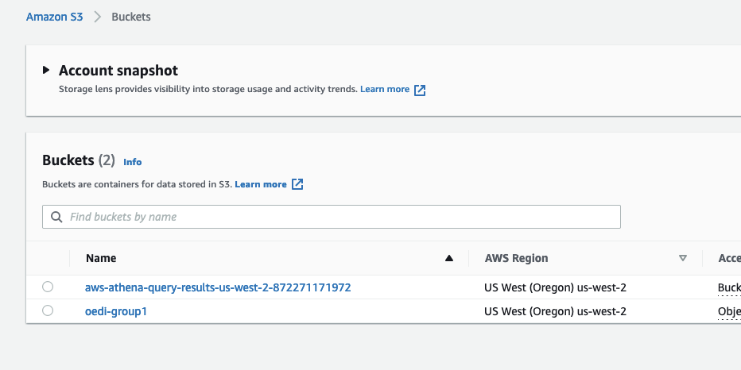

Created a Crawler

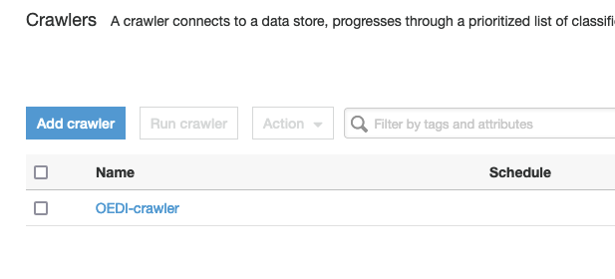

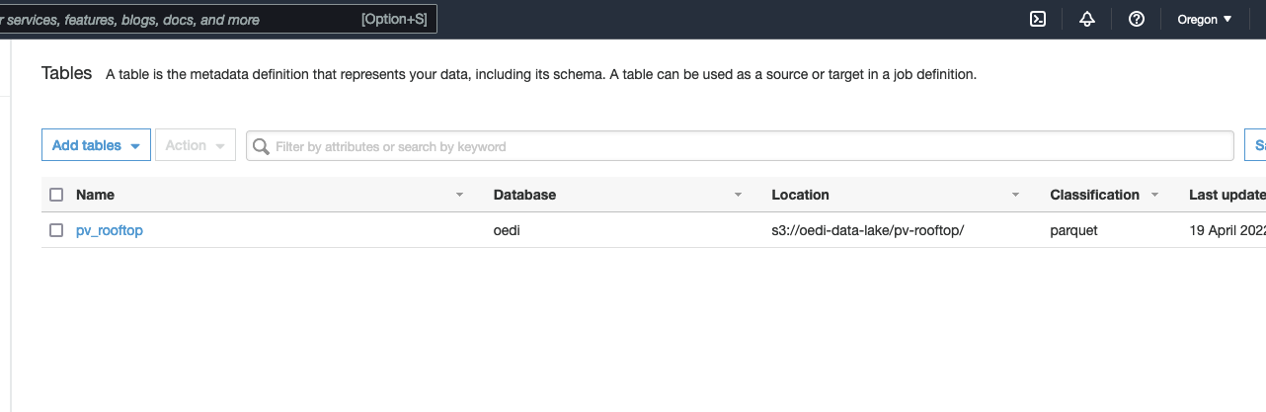

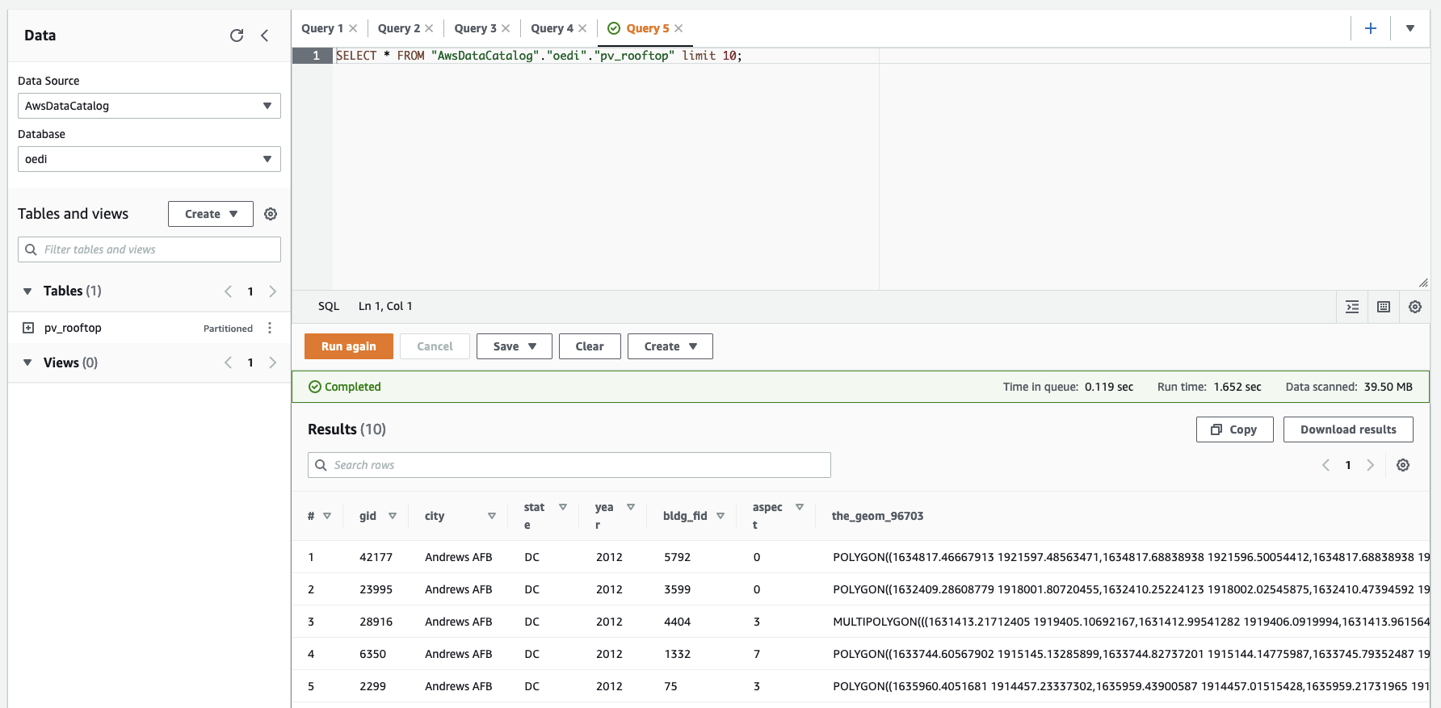

**6. Data Preparation**

Our goal is to find the area with the lowest overall slope with the highest amount of square footage possible for placing our solar panels. Our dashboard helps visualize our data to spot possible correlations between certain areas. Mainly, we’re looking for building ids and states with the lowest slope and the largest square footage to optimally place solar panels. In addition we need to account for the aspect of our geography in relation to the sun.

Our first graph depicts the average slope by footprint square footage. This is important for finding a threshold of average slope in an area by the footprint square footage.

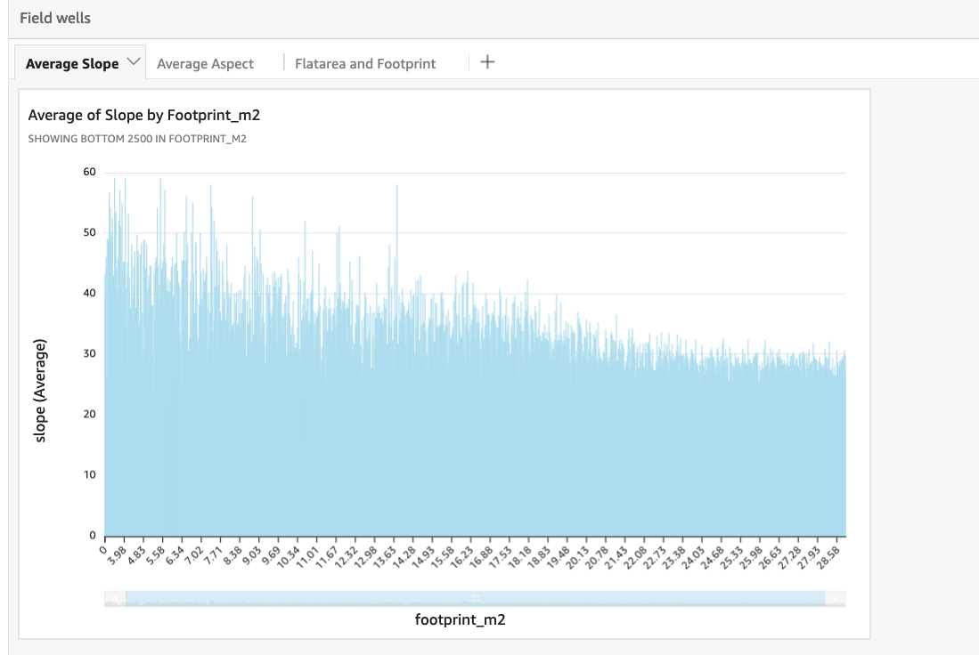

This graph depicts the average aspect by state. Aspect is critical for our problem as aspect determines how an area faces the sun with a higher aspect average resulting in a flatter surface area.

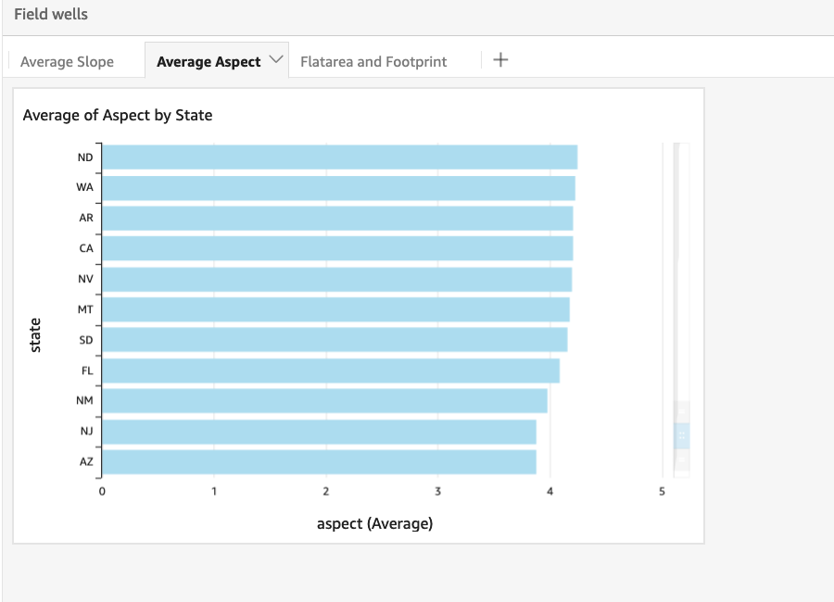

These graphs depict the square footage and footprint area by the building id of each area.

